So, now we have entered data into our table, we'll do the last few steps in this module and view the data.

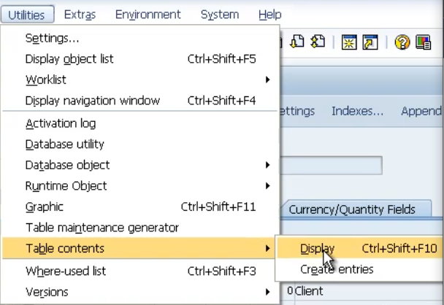

We'll go back to the Utilities menu, to the Table contents and choose Display.

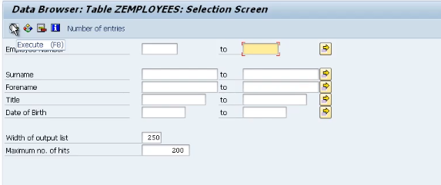

Now whenever we view a table through SE 11 or SE 16, SAP automatically generates a selection screen for us.

So if we don't want to view all the records initially, we can enter some filter values so that the system will only show us the records that we want to focus on.